Summer 2 Home learning ideas
‘How can we be superheroes?’
These home learning ideas are a choice and you can choose which one(s) you would like to complete. You may need help from an adult at home to complete some.
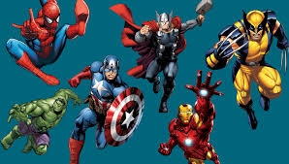

Tick off and bring in your home learning to share with the class once you have completed any.
Write a character description of your favourite superhero. | Create a ‘wanted’ poster for a missing superhero. | Dress up as a superhero – who are you and what is your superpower?
Create a report about your chosen super hero. | Research famous superheroes – why are they good at their job? | Create your own superhero comic. Can you remember what to use for direct speech?

