Summer 1 Home learning ideas
‘Would DT have helped traditional tale characters?’
These home learning ideas are a choice and you can choose which one(s) you would like to complete. You may need help from an adult at home to complete some.
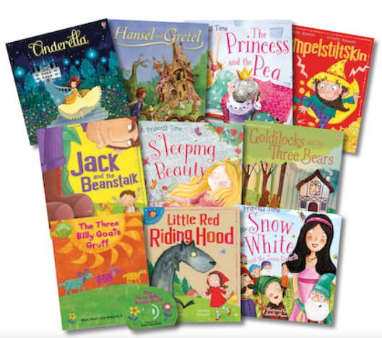

Tick off and bring in your home learning to share with the class once you have completed any.
Write a character description of your favourite character from a story. | Create a ‘wanted’ poster for a character. | Create a fairy tale story - what happens?
Write a play script of your own fairy tale. | Dress up as a character from your favourite book and describe what they look like. | Create your own ‘fairy tale’ with pictures to match!

