Spring 2 Home learning ideas
‘How can art help us find out about animals?’
These home learning ideas are a choice and you can choose which one(s) you would like to complete. You may need help from an adult at home to complete some.
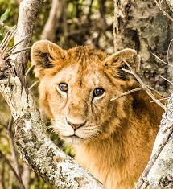
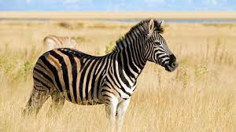

Tick off and bring in your home learning to share with the class once you have completed any.
Find out about different animals’ habitats. | Create some art work of your chosen animal. | Create an adventure story about going on a safari. What animals did you meet?
Research about foods that animals eat | Create an information text about your chosen animal. | Research about different animals around the world.
Visit a local zoo what animals did you see? | Create a model of a habitat for an animal of your choice. | Search famous people who know lots about animals!

