Spring 1 Home learning ideas
‘Who has been into space?’
These home learning ideas are a choice and you can choose which one(s) you would like to complete. You may need help from an adult at home to complete some.

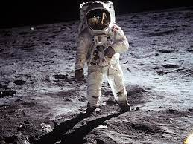

Tick off and bring in your home learning to share with the class once you have completed any.
Find out who the first person was to enter space. | Find out some amazing facts about space. | Create a newspaper article about life in space!
Research about foods that were ate in space. | Create a timeline to show different people who entered space. | Research what clothing was worn in space.
Find out about weather patterns in space. | Create an item such as a rocket made out of everyday items. | Search famous people who have visited space and how long they were there for.

