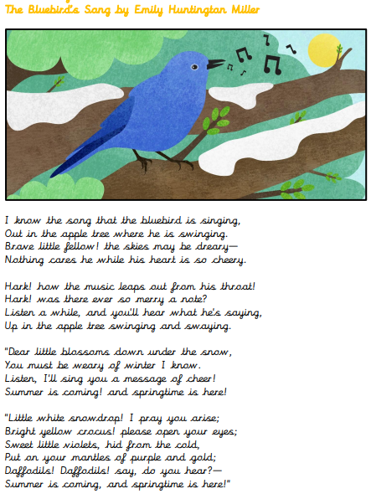
1.What does the word ‘swaying’ suggest about how he was moving?
2. What word could replace ‘leaps’ in the second verse?
3. Find and copy a word in the third stanza that means ‘regarded with deep affection’.
4. Find and copy a phrase in the first stanza that suggests the song was familiar to the author.

