Class 3 Topic work
Check out this link:
Impressionism | Tate Kids
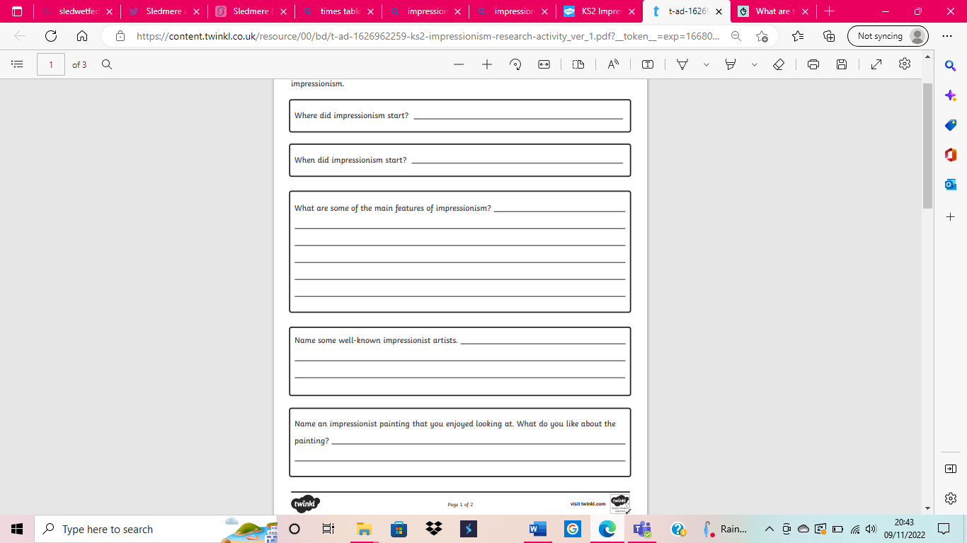
Can you use your own knowledge and other sources to research the answers to the questions below?
Extension – why not have a go at creating your own piece of impressionism artwork?

