11 12 13 14 15 16 17 |  |  |  |  | 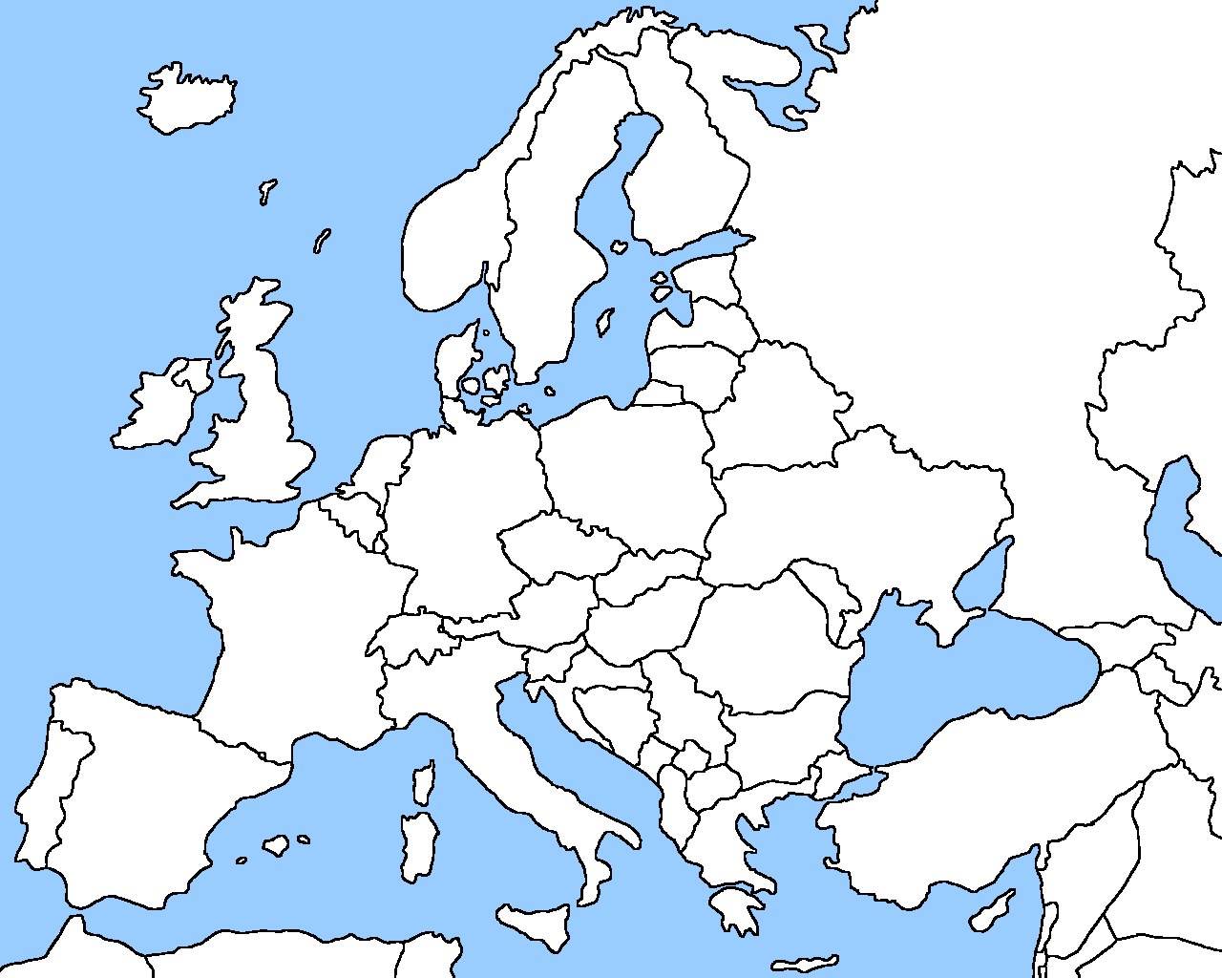
11 12 13 14 15 16 17 |  |  |  | 7
24 25 26 27 28 29 30 31 32 33
 | Country | Grid reference |  | Country | Grid reference
1 | Austria |  | 15 | Italy
2 | Belgium |  | 16 | Latvia
3 | Bulgaria |  | 17 | Lithuania
4 | Croatia |  | 18 | Luxembourg
5 | Cyprus |  | 19 | Malta
6 | Czech Republic |  | 20 | Netherlands
7 | Denmark | (26,15) | 21 | Poland
8 | Estonia |  | 22 | Portugal
9 | Finland |  | 23 | Romania
10 | France |  | 24 | Slovakia
11 | Germany |  | 25 | Slovenia
12 | Greece |  | 26 | Spain
13 | Hungary |  | 27 | Sweden
14 | Ireland
