Home Learning
Maths
The website below follows the maths we do in school. It contains videos to explain the maths and a worksheet for the children to work on after watching the video. At the bottom of the page on the White Rose site, you will find access to the Power Maths books that we use in school should you require extra questions.
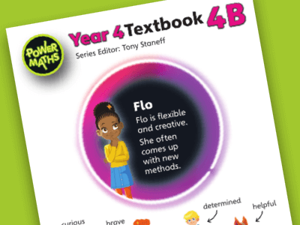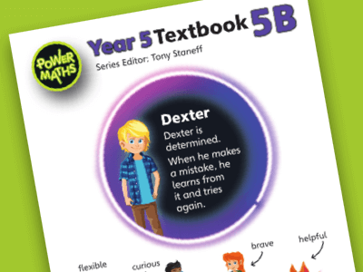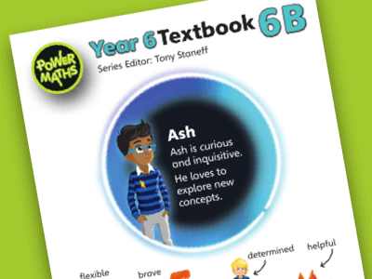
https://whiterosemaths.com/homelearning/
Further maths site:
https://mathshub.thirdspacelearning.com/resources/1875/9-Place-Value-Games-For-KS1-and-KS2

If you are looking for an extra challenge, you could try Nrich website as below. You will need to follow the primary tab at the top of the page and it will give you suggested age ranges on each problem.
https://nrich.maths.org/14580
https://nrich.maths.org/14569


Arithmetic
Fluent in five
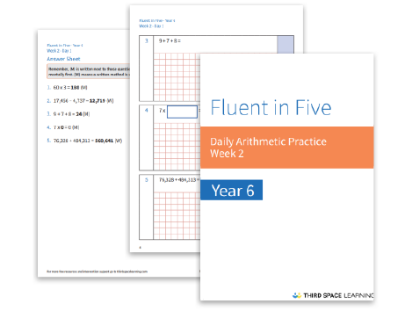
Year 4
https://mathshub.thirdspacelearning.com/resources/22/Fluent-in-Five-Arithmetic-Pack-Year-4-Weeks-1-to-6
Year 5
https://mathshub.thirdspacelearning.com/resources/21/Fluent-in-Five-Arithmetic-Pack-Year-5-Weeks-1-to-6
Year 6
https://mathshub.thirdspacelearning.com/resources/20/Fluent-in-Five-Arithmetic-Pack-Year-6-Weeks-1-to-6
Applying maths skills to different problems
Rapid Reasoning
Year 6
https://mathshub.thirdspacelearning.com/resources/1368/Rapid-Reasoning-Year-6-Weeks-1-to-6
Year 5
https://mathshub.thirdspacelearning.com/resources/1367/Rapid-Reasoning-Year-5-Weeks-1-to-6
Year 4
https://mathshub.thirdspacelearning.com/resources/1366/Rapid-Reasoning-Year-4-Weeks-1-to-6
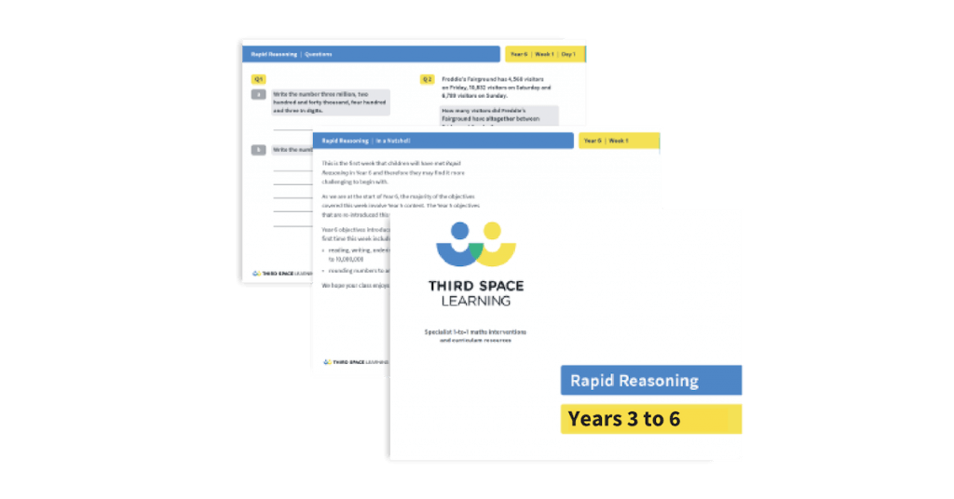
Times tables
https://mathshub.thirdspacelearning.com/resources/1931/Times-Tables-Packs-(Years-1-to-6)
https://ttrockstars.com/

English Reading Comprehension
This includes questions about texts to help children to understand what they are reading.
https://www.literacyshedplus.com/en-gb/browse/free-resources
https://classroomsecrets.co.uk/free-home-learning-packs/
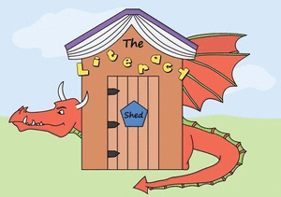
Reading
https://home.oxfordowl.co.uk/
https://www.worldofdavidwalliams.com/elevenses/
https://www.worldbookday.com/storytime-online/
https://stories.audible.com/start-listen
https://cornerstoneseducation.co.uk/news/free-access-to-cornerstones-love-to-read-resources-for-home-learning/
Science
https://www.stem.org.uk/home-learning/primary
https://www.stem.org.uk/home-learning/family-activities
https://www.bbc.co.uk/teach/ks2-science/zf3kt39
https://www.bbc.co.uk/bitesize/subjects/z2pfb9q (This will be available from the 20th April)
http://www.sciencefun.org/kidszone/experiments/
https://www.science-sparks.com/spring-science-activities/
English
This website gives you a starter and if you click on the PDF it gives you questions that you can explore for each picture.
https://www.astarterforten.co.uk/
The website below shows short videos that can help to stimulate writing. At the bottom of the page, below the video, are suggested writing ideas.
https://www.literacyshed.com/home.html
This website below shows a different picture everyday which can act as a stimulus for writing.

https://www.pobble365.com/
Children could write:
A short story
A character description
A setting description
A newspaper report
A letter
A diary entry or journal
An information text
An instruction text
In the home learning packs that I sent home with the children, you will find a sheet that explains the different types of text. Also included in the home learning folder was a sheet that has age appropriate expectations for your child.
Spelling, punctuation and grammar
https://classroomsecrets.co.uk/free-home-learning-packs/

French
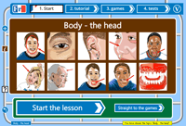
https://www.french-games.net/
Topic
Our topic this term is space and you could try some of the home learning ideas that are attached to the bottom of the main class page. There is also a copy in the home learning folders that your child brought home. I will change the topic for another one in a few weeks. I will add the new topic ideas to the bottom of the home learning page.

You may like to try this website for a home learning challenge!
https://cornerstoneseducation.co.uk/news/10-big-ideas-free-home-learning-challenges-for-children-and-families/

Keeping active
https://www.youtube.com/results?search_query=joe+wicks+pe
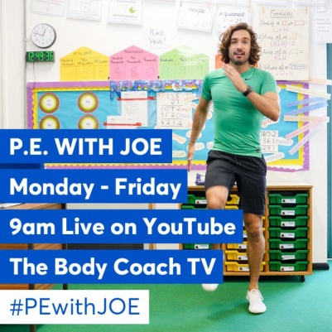
https://www.youtube.com/results?search_query=oti+mabuse

ICT
Purple mash
https://www.purplemash.com/sch/sledmereyo25


