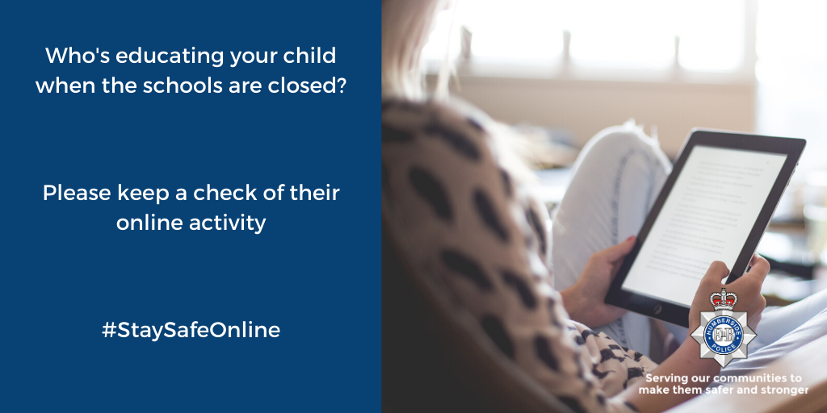
Cyber Prevent

Useful Links :-
https://www.thinkuknow.co.uk/
https://www.getsafeonline.org/
https://www.actionfraud.police.uk/
Useful Videos:-
https://www.youtube.com/watch?v=XhpeFG9hGm4&feature=youtu.be
https://www.youtube.com/watch?v=DjYrxzSe3DU



HP_Cyber
Humberbeat cyber crime

