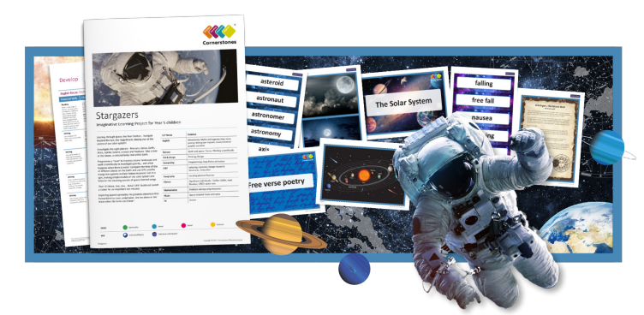
STARGAZERS
Journey through space – the final frontier! Let’s take a trip to the stars, planets and suns and discover the amazing wonders of the night sky. Our half term will kick off with our ‘Space Day’ when we will be entering a planetarium, carrying out rocket investigations and creating our own constellations. During this half term, we’ll be reading the book ‘The Jamie Drake Equation’ which will support our English objectives. We will investigate the cycle of day into night and how the seasons are created. Focusing on abstract art we will create art work inspired by Peter Thorpe. We’ll learn about Galileo, the ‘father’ of modern astronomy and his famous astronomical discoveries. We’ll investigate lunar myths and write astronaut poetry. At the end of the project, we will make a model of the Solar System.
English | Sci-Fi stories and newspaper reports
Science | Space
Art | Abstract art inspired by Peter Thorpe
DT | Model of the Solar System
History | History of space – The Space Race

