‘What is our local area famous for?’
Class 1 Autumn 1 Home learning ideas
These home learning ideas are a choice and you can choose which one(s) you would like to complete. You may need help from an adult at home to complete some.
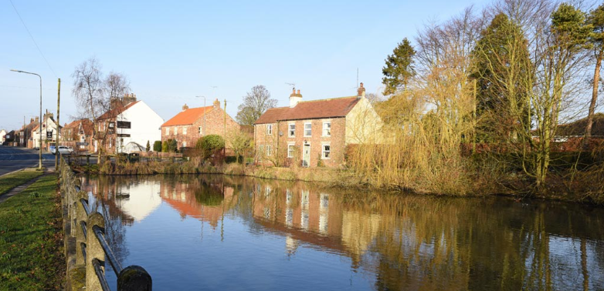

Tick off and bring in your home learning to share with the class once you have completed any.
Write some facts about the village of Wetwang that you can find out. | Find out about famous people who have been to Wetwang. | Write down your favourite things about living in a village.
Research about Wetwang School in the past. | Draw a map of a fictional village – what does your village have in it? | Write a letter to the Mayor of Wetwang.
Create a junk model of wetwang. | Find out about the artist David Hockney. | Describe some features of a village.

