Class 1 Newsletter Summer 2 2026

Welcome back to the final half term of the year! Summer 2!
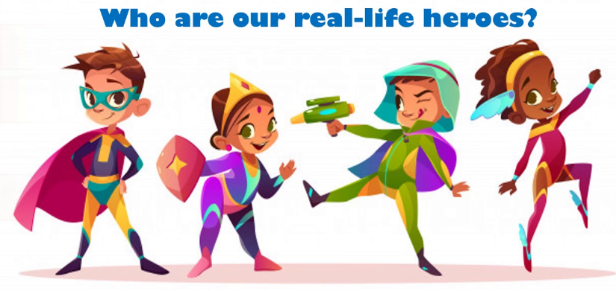
We have lots of exciting learning taking place this half term, trips out of school, visitors in school and lots of sporting events.
Our topic this half term is ‘How can we be superheroes?’
The children will be learning all about what makes a good superhero, James Rizzi Pop art, living things and their habitats and even designing and creating their own healthy fruit salad.
Topic title: How can we be superheroes?
Class stories: | Superheroes
English | Superhero cartoons, instruction texts and superhero stories.
Maths | Time, fractions, statistics
Science | Living things and their habitats
Computing | Maze explorers and coding.
DT | Design, make and evaluate a healthy fruit salad
R. E | What a wonderful world – why is the world special?

PE
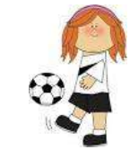
PE for all children PE will take place on alternate Monday afternoons, Wednesday and Friday afternoons.
Children will continue to have access to a range of resources to promote physical development as part of the outdoor provision. For PE lessons a named indoor and outdoor PE kit is required, this includes dark coloured shorts, a school PE top, track suit and suitable running shoes. Please name everything to ensure lost and found items can be returned easily.

Water Bottles
So that your child can have access to water throughout the day, please provide an ‘unleaky’ named water bottle which can be kept in the classroom or taken to PE. Failure to do so means that adults waste learning and interaction time finding, filling and washing numerous cups. Water, being the healthiest option, is preferable to juice. Thank you
Reading for Reception and Y1/2 children

Practise makes perfect! Please ensure that school reading books and yellow reading records are brought to school every day. This allows us to practise with your child in school (wherever possible) and keep up to date with renewing books. Your child will take part in guided reading sessions four times a week. In addition to this please practise regularly at home, little and often is more effective than once or twice a week. A reward system (the reading rocket and raffle tickets) are in place in school to encourage children to read at home.

Times tables – KIFS (Key instant recall facts)
Children in Class 1 and 2 will be learning Key Instant Recall Facts (KIRFs) in maths.
Reception focus: To know even and odd numbers up to 10.
Year 1 focus: To count in 2’s, 5’s and 10’s.
Year 2 focus: To know and revise the 2,5 and 10 times tables (mixed with division facts).
Please practise these at home. Little and often is best. See our class page on the website for more information.
A letter will be stuck each half term in your child’s maths homework book explaining the KIRF that your child is learning each half term and will need to be supported with learning them at home too.

Homework
The children in class 1 will get maths KIRF homework every week. Year 1 and 2 children will take home weekly spellings. The spelling test will also take place on Friday and their test will be marked and put in their spelling book for parents to see their score.

Owl Time and Library Time
Owl Time is where children can bring a book from home to read or share. This will take place every Friday. On Friday’s children will also have the opportunity to choose a school library book to share at home.

Important dates
Important dates are included on the school newsletter which can be accessed easily on the school website - sledmerewetwangfederation.co.uk. If you have any questions or concerns about your child, or if you have any skills or resources that can enhance our topic, please don’t hesitate to get in touch.

Many thanks for all of your support,
Mrs Darioglu

