‘What was school like in Victorian times?
Class 1 Autumn 1 Home learning ideas
These home learning ideas are a choice and you can choose which one(s) you would like to complete. You may need help from an adult at home to complete some.
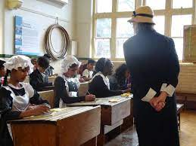
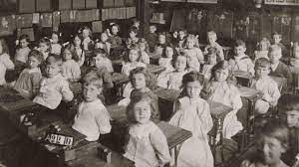

Tick off and bring in your home learning to share with the class once you have completed any.
Create a Victorian school item such as a bell, cane or ink pen. | Find out some facts about the Victorian times. | Find out what it was like to be a child in Victorian times.
Research about Victorian school clothing. | Compare Victorian and modern day schools. | How do children from Victorian to modern day differ?
Create an object that was used in the Victorian times. | What toys did Victorian children play with in the past? | Make a Victorian toy from the past.

